Level 2 Trophy Training 
- Fork: attack two pieces with one move:
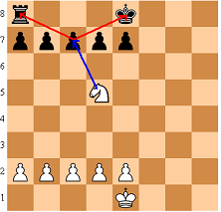
- Pin: attack a piece that can’t move anymore after your move:
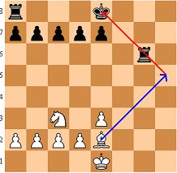
- Discovered check: give a check by moving one of your pieces out of the way:
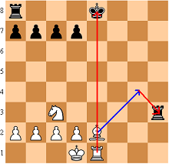
Win with King+Rook versus King
A key position is:
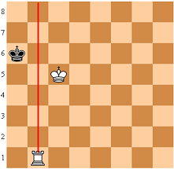
Don’t let the black king escape from the side of the board.
When it’s black’s move chase the king. Give mate as soon as the black king is opposite the white one.
When it’s white’s move waste a move to force black to move.
Chess notation
Enthusiastic chess players keep score of important games. They write down the moves. Later, they can show nice victories to their friends and coach. They can also learn from their mistakes by replaying the game later together with their coach. Example:
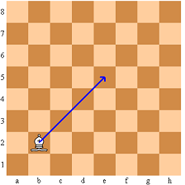
The above move “Bishop from b2 to e5” is recorded as Be5.
K is used for King, Q is Queen, R is Rook, B is Bishop, N is Knight (the “K” is already in use!)
Example of a game with the 4 move check mate:
1. e4, e5 (first move: white pawn to e4, black pawn to e5)
2. Qh5, Nc6 (second move: white Queen to h5, black Knight to c6)
3. Bc4, Nf6? (third move: white Bishop to c4, black Knight to f6)
4. Qxf7 mate (fourth move: white Queen takes (x) f7 with mate)
1-0 (white wins (0-1 means black wins, ½-½ means draw))
0-0 is used for king side castling, 0-0-0 for queen side castling
With rooks on a1 and c1 “Rb1” is confusing. We have to add which rook: “Rab1” or Rcb1”.
A question mark can be added for a bad move (for example: 3…,Nf6?), an exclamation mark for a good one.

Example of a score sheet:
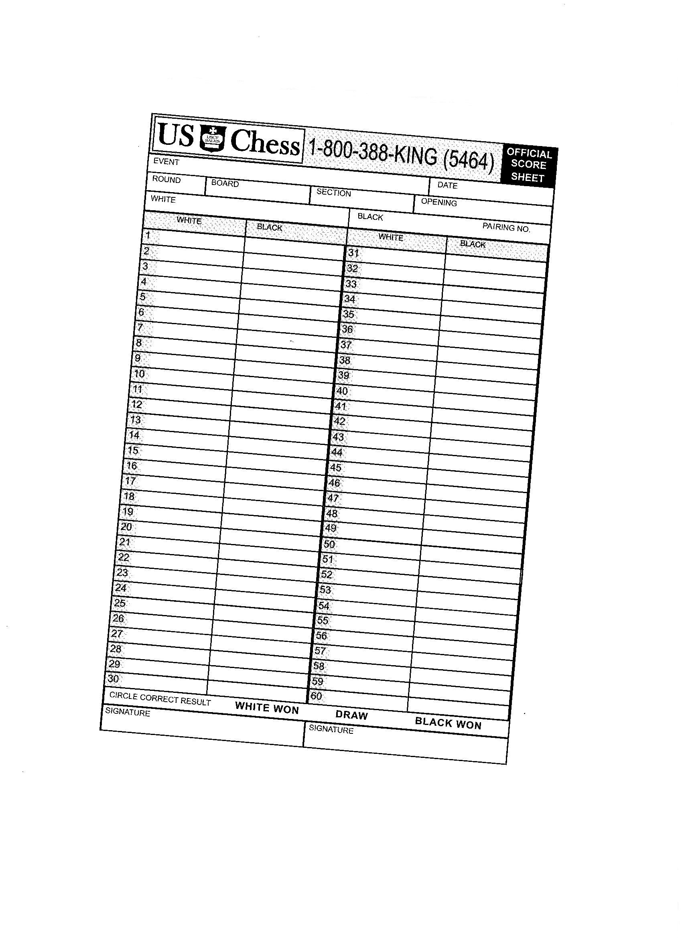

Win King+Pawn versus King with King in front of the pawn
White begins and wins:
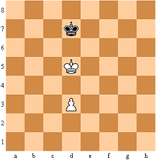
Strategy: when the Black King goes to one side, the White King goes forward to the other side to make room for the pawn to promote. When it’s White turn to begin, White must force Black to make a choice first.
Therefore, White begins with wasting a move doing 1.d4
Now, it’s Black’s turn! As soon as Black chooses a side White takes the other one:
